DEVELOPING A THEORY OF CHANGE

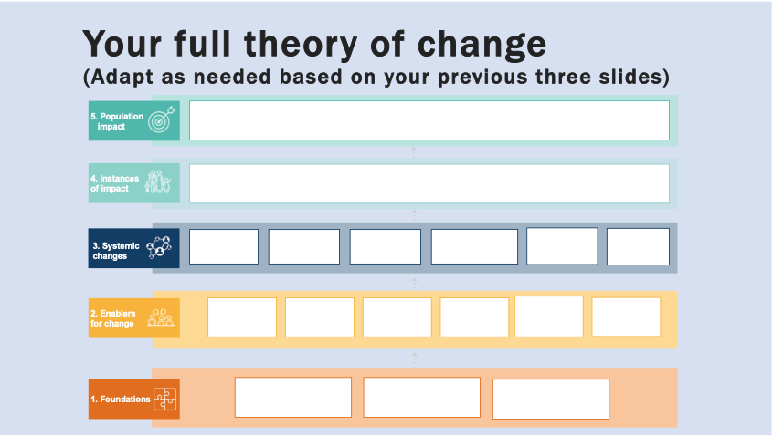

GROUP EXERCISE
Describe your collaborative’s theory of change by answering the questions below.

- What is the population-level impact our collaborative seeks to make?

- Instances of impact: Who is the target demographic(s) that we seek to impact (i.e., youth disengaged from school and work, single mothers, seniors, low-income neighbourhoods, etc.)?

- A) What are the systems that need to change in order to create the desired impact for our target demographic(s) (i.e., policies, practices, resource flows, relationships and connections, power dynamics, mental models, etc.)?

B) How can these systems change outcomes be achieved? What is our contribution (activities) to achieving this change?

- A) Enablers: What key factors that must be present or absent to succeed in making these system(s) changes? (i.e., strategic learning, authentic engagement, transparent and inclusive governance, capacity building, high-leverage activities, multi-sector collaboration, etc.)

B) What needs to change about these key enablers? How will we contribute to developing the key enablers needed for systems change? (i.e., strategic learning, authentic engagement, transparent and inclusive governance, capacity building, high-leverage activities, multi-sector collaboration, etc.)

- A) What are the foundations (pre-conditions) that must be established in order influence and change the enablers? (i.e., community and agency readiness, history and context of place, sufficient resources)

B) What is our contribution (activities), if any, to developing these pre-conditions for change?

- What are our key assumptions in this Theory of Change? (ex. Having a job raises people above the poverty line; graduation rates are a good indicator of an educated population; etc.)

