THE FRAMING CHALLENGE

Challenge: There is no agreed upon definition of poverty nor impact framework.

Our solution: Collaboratives must develop and embrace their own version of an impact framework, feel comfortable with their rationale, and communicate this framing to stakeholders.

To overcome this challenge, implicit frameworks must be made explicit and collaboratives that have been reluctant to commit to the elements of a formal framework in order to be inclusive of partners, need to commit to something. The following nine resources briefly describe some typical poverty reduction frameworks that collaboratives may consider adopting or adapting. If none of these frameworks speak to your understanding of poverty, you may need to develop, test and refine a framework from scratch.

The basic elements of a framework include:
- Your definitions of ‘poverty’ and ‘poverty reduction’
- Your impact domains (ex. Housing, education, health, etc.)
- Your indicators (against impact domains)
- Your poverty threshold(s)

  - Table 2 – Table of Contents: Typical Frameworks
 | Framework | Page Number
Programmatic & Targeted- Level
1 | Self-Sufficiency Scales | Page 2
2 | Sustainable Livelihoods | Page 2
Population-Level – Unidimensional, Income-Based Measures
3 | Market Basket Measure (MBM) | Page 3
4 | Low Income Measure (LIM) | Page 3
5 | Low-Income Cut Off (LICO) | Page 3
Population-Level – Multidimensional
6 | Deprivation Indexes | Page 4
7 | Social Determinants of Health | Page 4
8 | Canadian Index of Wellbeing | Page 5
Population-Level – Quasi Uni/Multi Dimensional
9 | Opportunity for All | Page 5

Programmatic & Targeted Level Frameworks

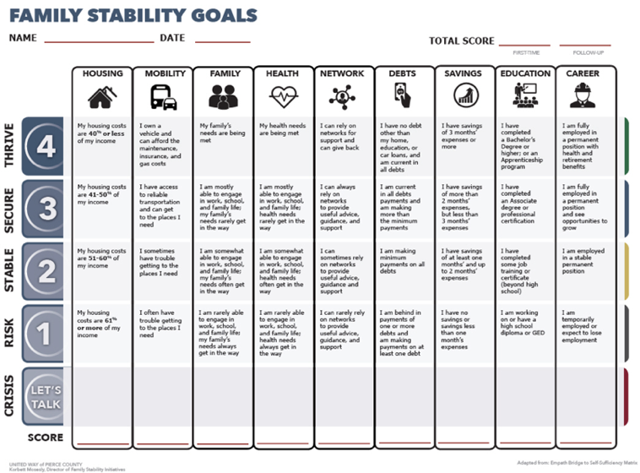
- Self-Sufficiency Scales
- Scales help assess degree of a person’s self-sufficiency from minimal to maximal self-sufficiency.
- Tracks against 18-24 different domains.
- Well-documented and tesed.
- Popular amongst practitioners and policymakers in healthcare, social services, and related fields. Particularly used in the United States.
- Limitations: Language doesn’t appeal to everyone; may be too rigid.

Read more about self-sufficiency scales

- Sustainable Livelihoods
- Asset-based framework; uses positive language (ex. building resiliency, resiliency assets).
- Poverty reduction is the accumulation of ‘livelihood assets’ in five domains (financial, human, social, personal, and physical) until individuals are resilient enough to climb out of poverty and can prevent from falling back into it.
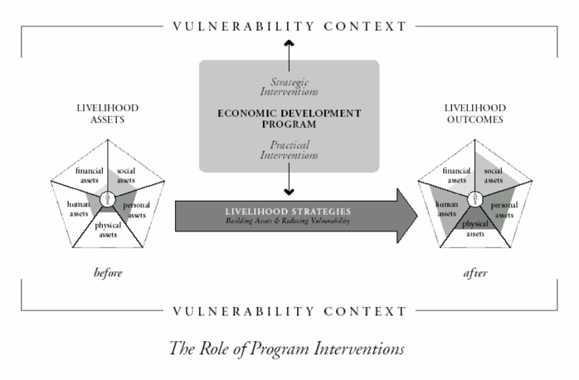
- Can be a design tool or assess progress against systems change and programmatic interventions.
- Measure progress in five major and dozens of minor domains of impact (ex. financial assets include income, savings, etc.).
- Allows participants to track their journey from crisis to thriving.
- Widely used in international development and some poverty reduction work in Canada.
- Limitations: time intensive; difficult to aggregate and compare results; no common ‘threshold’ under each domain.

Read more about Sustainable Livelihoods

Population-Level Frameworks – Unidimensional, Income-Based Measures

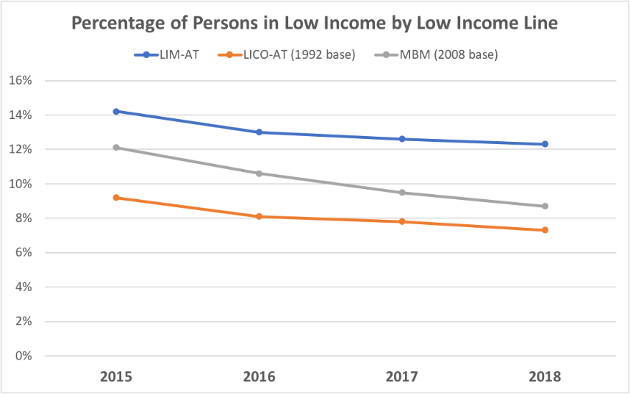
- Market Basket Measure (MBM)
- Measures low income based on the cost of a specific basket of goods and services representing a modest, basic standard of living; adjusted for family and community size
- This income measure is more sensitive than LICO to different costs of living in various provinces and cities; is now considered a more valid indicator of poverty than LICO
- Limitations: only tracks income; updated every five years with an 18-month publication delay based on census data; currently only tracks 50 communities

Read more about the MBM

- Low-Income Measure (LIM)
- Low income is defined as 50% of median income, adjusted for family and community size.
- Choice to track pre-tax, post-tax or market income.
- Statistics released annually, based on tax-filer data.
- Used as the international standard for measuring low-income.
- Limitations: Cost – it must be purchased from Canada Revenue Agency; only tracks income.

Read more about LIM

- Low-Income Cut-Off (LICO)
- Low income is defined as spending 20% or more than the average family on basic necessities such as food, shelter and clothing; adjusted for family and community size.
- The most historically understood ‘proxy’ of income poverty and widely known
- Data is broken down by geographic (including neighbourhood-level) and demographic groups
- Limitations: Only tracks income and updated every five years with an 18-month publication delay based on census data.

Read more about LICO

Population-Level Frameworks – Multidimensional
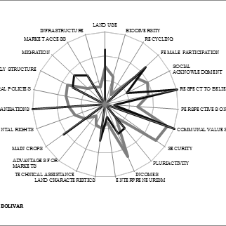
- Deprivation Indexes
- Tracks and ranks material and social deprivation in Canadian cities employing a multi-dimensional understanding of wellbeing.
- Data at four levels: National, regional, Census Metropolitan Area (CMA), and geographic zone (major cities, medium cities, census agglomerations and small towns & rural regions).
- Compiled by professional researchers, has high credibility and reliability.
- Data is free.
- Limitations: Updated every five years with an 18-month publication delay based on census data; focuses on ‘deprivation’ (deficit-based language)

Read more about deprivation indexes.

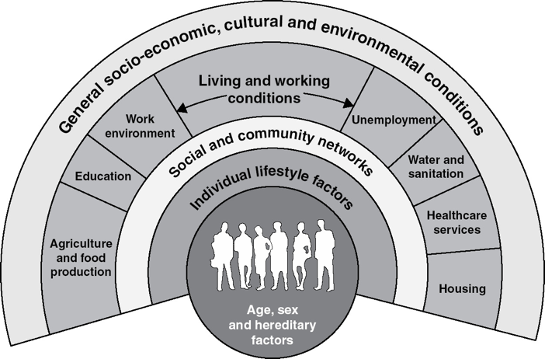
- Social Determinants of Health
- 12 social and physical conditions in which people live are root causes of and measures of health and wellbeing.
- Used extensively by Health Canada and many provincial agencies.
- Relatively well-known.
- Limitations: Not considered a poverty framework by all; provides guidance on strategies but not measurements and therefore has little evaluation consistency across communities; requires extensive data collection.

Read more about the Social Determinants of Health here and here

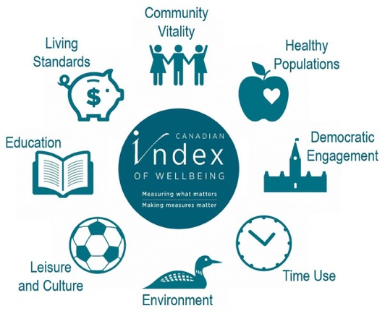
- Canadian Index of Wellbeing
- Uses a multidimensional framework to evaluate overall quality of life in Canada.
- Tracks 64 community-level indicators under eight domains (leisure and culture, environment, democratic engagement, health, education, time use, vitality, and living standards).
- Compiled by researchers, data is the most credible and reliable multidimensional framework at the community-level.
- Limitations: Difficulty benchmarking the information with other cities; each analysis contracted through the University of Waterloo which can create accessibility issues.

Read more about the Canadian Index of Wellbeing

Population-Level Frameworks – Quasi Multi/Uni-Dimensional

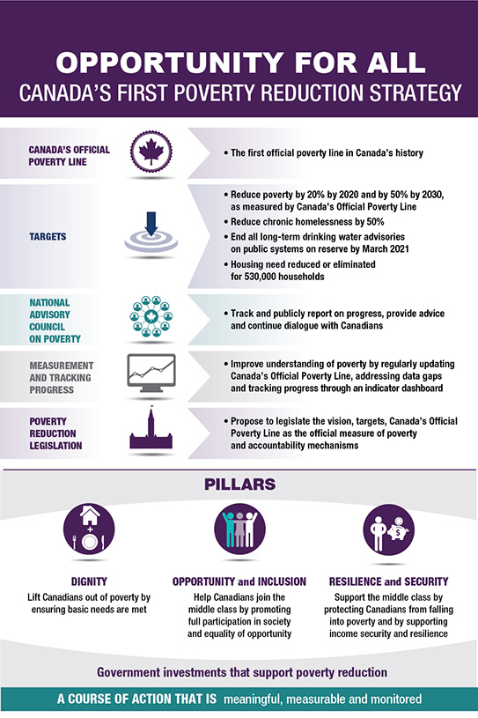
- Opportunity for All
- Sets the Market Basket Measure (MBM) as the ‘official’ poverty line, complemented by a scorecard of indicators of poverty reduction.
- Tracks multiple dimensions of poverty at the population-level and is disaggregated by community, household size and demographic groups – more than any other measures.
- Useful if wanting to align with Canada’s poverty reduction strategy and are interested in tracking more than just income poverty.
- Will have strong credibility and reliability, as it is being developed by professional researchers.
- Likely to become the optimal measure of poverty at the population-level in Canada.
- Limitations: Largely income and/or material deprivation-based, may be considered too ‘partisan’; as of yet, has not been implemented.

Read more about the Opportunity for All dashboard

GROUP EXERCISE
Purpose: Finish building a common understanding of what poverty and poverty reduction are in your context.
Describe your impact framework:
- Your working definitions of ‘poverty’ and ‘poverty reduction’

- Your domains (ex. Housing, education, health etc.)

- Your indicators (against impact domains)

- Your poverty threshold(s)

